Project Report

On

Shop Billing System
(A computer Hardware shop)

School of Computer Science(B.Tech CSE)
University of Petroleum and Energy Studies
Instructor: Dr. Prashant Trivedi
Course: Programming in C

Submitted By:-
ISHA VIJAY

Sap Id : 590027876
Course code: CSEG1041
ABSTRACT
• WHAT THIS PROJECT DOES ??
This project develops a shop billing system in the C programming Language that records the components like what the customer wants and automatically calculates bill based on the customer input.
• WHY IT IS USEFUL ??
It simplifies the billing calculation process by eliminating manual errors saving time and providing a clear and accurate calculation of the bill in a standard manner
• HOW IT WORKS AT A HIGH LEVEL ??
The system takes various choices from user by displaying a proper menu as input processes and then by using functions, switch-case,while loop, goto statement, break statement, continue statement and various c-programming elements computes required bill and displays the final bill along with a confirmation message(whether they want to continue with the purchasing) and generating a ending mesaage accoring to user input of confirmation of order.

TABLE OF CONTENTS
- Introduction (Problem Definition)
.............................................................................4
- System Design (Flowcharts, Algorithms)
.............................................................................6
- Implementation Details (with snippets)
.............................................................................9
- Testing & Results
.............................................................................11
- Conclusion & Future Work
.............................................................................17
- . References
..............................................................................18
- Appendix
..............................................................................19
INTRODUCTION(Problem Definition)
Billing is one of the most essential tasks in any shop—whether it is retail, wholesale, or any other type of business. Managing cash accurately is very important, and when billing is done manually, it often becomes slow, tiring, and prone to mistakes. Even a small calculation error can lead to confusion and sometimes major financial losses. Because of this, having an automated billing system that can calculate bills correctly and save time has become necessary. The Shop Billing System developed in this project aims to handle the entire billing process smoothly by calculating the total amount and generating a final bill for the customer.
The shop chosen for this project is a computer hardware store that sells different computer components and also helps customers build or customize their own PCs. To make the billing process easier, the system first displays a menu listing all the available products along with their prices. This makes it clear for the operator to choose the items without any chance of mixing up product names or prices.Many small and medium hardware shops still depend on manual billing. This creates several issues such as slow service, calculation errors, mismanagement of records, misplaced bills, and difficulty in keeping track of daily or monthly sales. Manual billing also becomes stressful when there are many customers waiting, especially during busy hours.
Scope of the Project
This billing system is designed just to mainly focus on billing. It first presents or displays menu in front of the customer and lets them select whatever product they want and later on generate a fully trusted bill without any error that would have occured if the bill was generated by human. It is simple, effecient and even suitable for small shops.

Features of the System
- User-friendly and easy to operate
- Automatic calculation of totals
- Quick billing during rush hours
- Error-free bill generation
- Menu-based navigation
- Saves time and reduces workload
Technology Used(Language used)
C programming language is used for developing this system. It is built on using concepts like declaring a user-defined functions, calling functions, creating variables, using switch statement, basic mathematical operations. It’s interface is lightweight and simple.

System Design (Flowcharts, Algorithms)
a) The billing system structure:
START
Welcome message
Inquiring personal details
Displaying the menu
(With all the components
present in the shop)
Generating a bill
Asking for confirmation
Yes No
Confirms the order Unconfirms the order
END
b) The internal working
To inquire personal details
Calls the personal detail function
(Declared before the main function)
Displaying The menu
1. processor menu
(calling processor menu function)
2. Graphics card menu
(calling graphic card menu function)
3.Ram menu
(calls ram menu function)
4.Storage
(calls storage menu function)
5.Other accessory
(calls other accessory function)
6.Monitor
Yes No
(Adds monitor Removes the
in the cart) monitor from
the cart
Order summary
Displaying the Generating the total
items bought amount of the
purchase

Order confirmation

Yes No
order placed order cancelled

Implementation Details
(With Snippets)

1. Program Structure
Program Organization:
- Number of files: Single main.c file
- Header files Used(standard Library used): <stdio.h>, <string.h>
#include <stdio.h>
#include <string.h>
2.User- defined function:
- void personal_details(): Personal details function
- void processormenu(): Processor menu function
- void graphiccardmenu(): Graphic card menu function
- void rammenu(): Ram menu function
- void storagemenu(): Storage menu function
- void otheraccessorymenu(): Other acsessories menu function
- float totalPrice(float a, float b, float c, float d, float e, float f, int g): Total
price function
// declaring functions
void personal_details(); //Personal details function
void processormenu();//processor menu function
void graphiccardmenu();// graphic card menu function
void rammenu();//ram menu function
void storagemenu();//storage menu function
void otheraccessorymenu();//other acsessories menu function
float totalPrice(float a, float b, float c, float d, float e, float f, int g); //Total price function

3. Data variables(User defined Variables):
All variables defined were global variables:
- name: For inputing name.
- mobile_number: For mobile number
- choice, choice1, choice2, choice3, choice4, choice5, choice6: For Getting input in If..else statement and switch
- quantity: For taking quantity from user
- processorPrice , gpuPrice, ramPrice , storagePrice, otherPrice, monitorPrice : For intializing price of various goods in the shop.
- processor, gpu, ram, storage, other, monitor: For taking value fro user an putting it into the output
//declaring variables
char name[50];
long long mobile_number;
int choice,choice1,choice2,choice3,choice4,choice5,choice6;
int quantity;
float processorPrice = 0.0, gpuPrice = 0.0, ramPrice = 0.0, storagePrice = 0.0, otherPrice = 0.0, monitorPrice = 0.0;
char processor[30], gpu[40], ram[10], storage[30], other[200], monitor[20];

4. Control Structures
Logical structures used:
1. Switch-case: for menu of various good
2. If.... else : Asking for logical operators
3. while loop : For other accessory menu
if(choice6 == 1){
printf("\n (^ _ ^) Yay! %s Your order has been placed successfully.\n",name);
printf("\nThank you for shopping with ISHVIT CORPORATIONS!\n");
}else{
printf("\n (>_<) Order cancelled.\n");
printf("See you next time %s, till then byee, have a great day!!",name);
}

5. Input Handling
- scanf() :For taking mobile number from the user.
- fgets() :For reading name of the customer
printf("Please enter your name:");
fgets(name, sizeof(name), stdin);
name[strcspn(name, "\n")] = 0;
printf("Enter your mobile number:");
scanf("%lld",&mobile_number);

6 . Error Handling

Invalid input statement in switch to handle invalid input given by the user:
default:
printf("INVALID INPUT \n"); printf("Choose Again \n"); continue;
} break;

7. Final Output Format
1. The final output will be in a table format i.e the order summary
2. The confirmation and decline of the order will be followed by an Ascii emoji and the following end prompt.
// Order Summary
printf("Hi %s here is your order summary,Please check!!",name);
printf("\n=====> ORDER SUMMARY <=====\n");
printf("Processor: %s\n", processor);
printf("GPU: %s\n", gpu);
printf("RAM: %s\n", ram);
printf("Storage: %s\n", storage);
printf("Other: %s\n", other);
printf("Monitor: %s\n", monitor);
printf("Quantity: %d\n", quantity);
printf("----------------------------\n");
printf("Total Price: $%.2f\n", price);
printf("============================\n");
// Confirmation
printf("\nConfirm Order?\n1. Yes\n2. No\nEnter choice (1-2): ");
8. Control transfer statements
1. Break statement: To break the loop.
2. Continue statement: To continue the loop but skip a particular part.
3. Goto statment:To go to a particular part of the program.
default:
printf("INVALID INPUT \n"); printf("Choose Again \n"); continue;
} break;
Testing & Results :
1. It is the whole layout of the billing system of the shop:
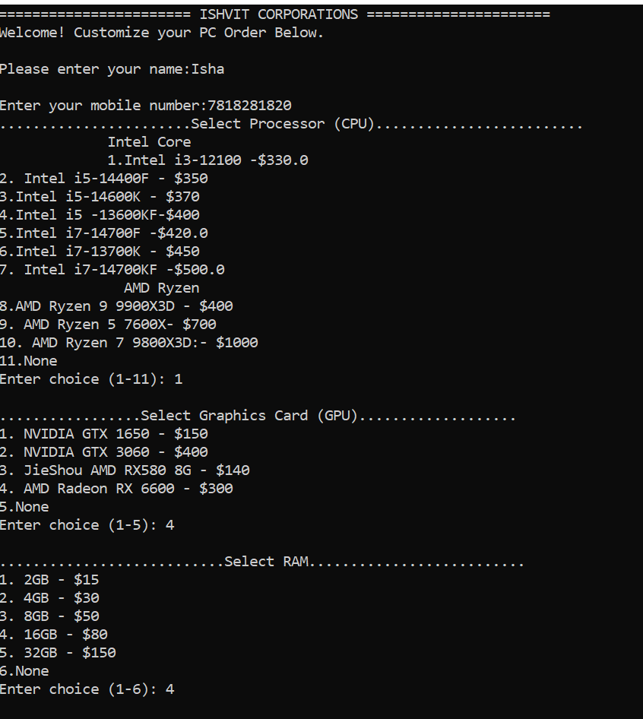
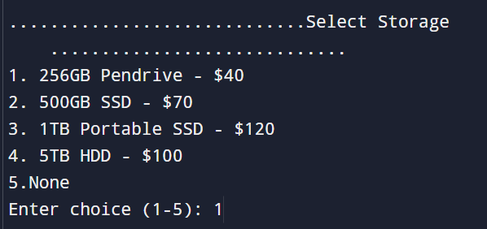
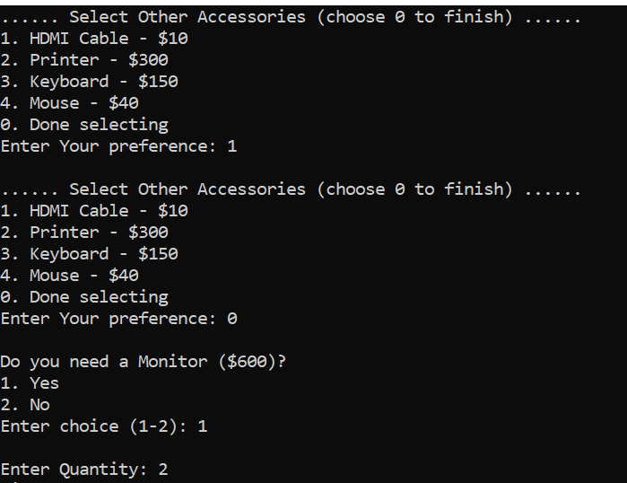
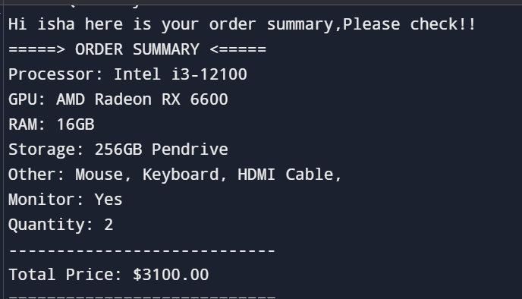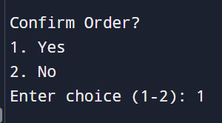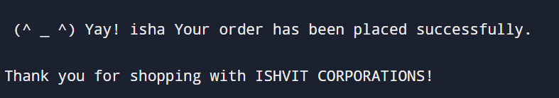
2. When the Input in “Invalid” that is the user gave an input that was not in the menu, therefore the user will be prompted to give input again:
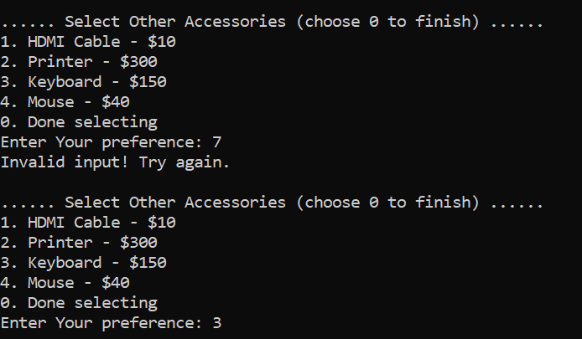
3. In Select other accessories menu the user is allowed to choose multple inputs and will only stop asking when the user presses “0”:
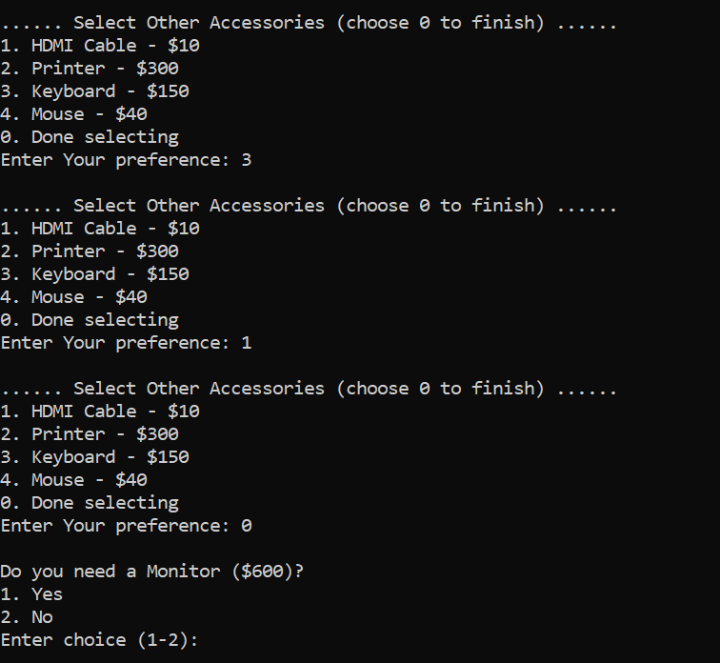
4 . If the user selects no option in monitor(Then monitor will not be selected.
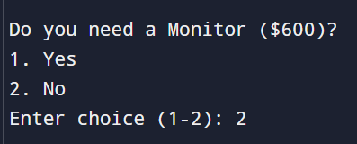
5. If the user Puts none option then the price of that product is not calculated:
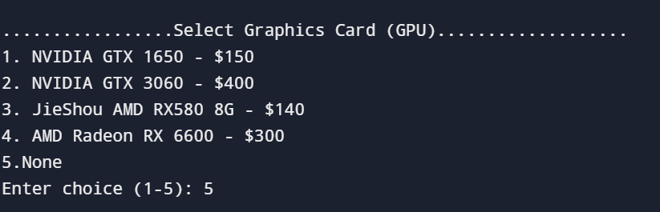
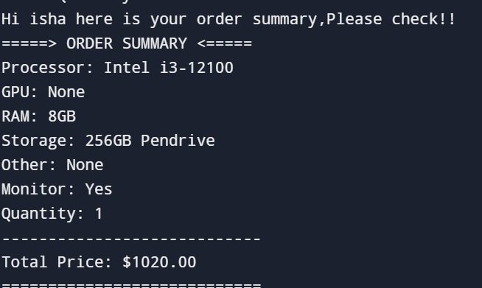
5. This is the asking for the user to if the input given by user is correct or not !!
6. After checking the order summary the user can give perimission(If they are okay with the order or not).
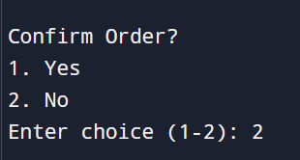
7. If the user confirms the order:
8. If the user declines the order:
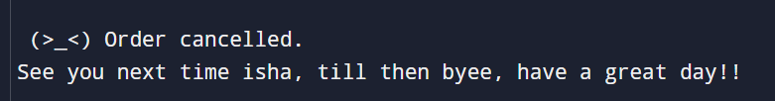
Conclusion & Future Work
In conclusion, accurate billing is a must in this technical era and creating a system that can not only generate accurate results but also save time on the long run. Any billing done manually is prone to errors. Therefore, I have created a generalized system that will first provide you with a menu and later on will generate a bill according to your selected components. The billing systen is for a computer hardware shop and ensures that no error is made, so as to maintain that no errors are made.
Future Scope: Further modification for future :
- Connecting this file to a database that can store the details of the regular customer and also the information regarding the customers that came on a particular day, basically it can include the overall information about the shop and what is happening in the shop.
- New hardware items bought can also be added in the menu as space for future addition is there.
- In the future it can also provide a data analysis and prepare a chart regarding the sales of that company.
- In future It can have Graphical-User Interface(GUI).
- 5. It can also generate the bill in a pdf format.
References
Github link:
C- Project Link: https://github.com/Ishavijay/C-Project

Appendix
Code:
#include <stdio.h>
#include <string.h>
//declaring variables
char name[50];
long long mobile_number;
int choice,choice1,choice2,choice3,choice4,choice5,choice6;
int quantity;
float processorPrice = 0.0, gpuPrice = 0.0, ramPrice = 0.0, storagePrice = 0.0, otherPrice = 0.0, monitorPrice = 0.0;
char processor[30], gpu[40], ram[10], storage[30], other[200], monitor[20];
// declaring functions
void personal_details(); //Personal details function
void processormenu();//processor menu function
void graphiccardmenu();// graphic card menu function
void rammenu();//ram menu function
void storagemenu();//storage menu function
void otheraccessorymenu();//other acsessories menu function
float totalPrice(float a, float b, float c, float d, float e, float f, int g); //Total price function
int main() {

printf("======================= ISHVIT CORPORATIONS ======================\n");
printf("Welcome! Customize your PC Order Below.\n\n");
//calling personal details function
personal_details();
// Processor Menu
processormenu(); // calling processor menu function
graphiccardmenu(); // calling Graphics card Menu function
rammenu(); // calling RAM Menu function
storagemenu();// calling storage menu function

otheraccessorymenu(); // calling Other Accessories Menu function
// Monitor Optiion
S1:
printf("\nDo you need a Monitor ($600)?\n1. Yes\n2. No\nEnter choice (1-2): ");
scanf("%d", &choice5);
if(choice5 == 1) {
strcpy(monitor, "Yes"); monitorPrice = 600.0; }
else if (choice5 == 2)
{ strcpy(monitor, "No"); monitorPrice = 0.0; }
else{
printf("Invalid Input!!\n"); printf("Choose again");goto S1;
}// Quantity

printf("\nEnter Quantity: ");
scanf("%d", &quantity);

//calling total price function to calculate the total price of the material bought
float price= totalPrice(processorPrice,gpuPrice,ramPrice,storagePrice,otherPrice,monitorPrice,quantity);

// Order Summary
printf("Hi %s here is your order summary,Please check!!",name);
printf("\n=====> ORDER SUMMARY <=====\n");
printf("Processor: %s\n", processor);
printf("GPU: %s\n", gpu);
printf("RAM: %s\n", ram);
printf("Storage: %s\n", storage);
printf("Other: %s\n", other);
printf("Monitor: %s\n", monitor);
printf("Quantity: %d\n", quantity);
printf("----------------------------\n");
printf("Total Price: $%.2f\n", price);
printf("============================\n");

// Confirmation
printf("\nConfirm Order?\n1. Yes\n2. No\nEnter choice (1-2): ");
scanf("%d", &choice6);

if(choice6 == 1){
printf("\n (^ _ ^) Yay! %s Your order has been placed successfully.\n",name);
printf("\nThank you for shopping with ISHVIT CORPORATIONS!\n");
}else{
printf("\n (>_<) Order cancelled.\n");
printf("See you next time %s, till then byee, have a great day!!",name);
}
return 0;
}
//---------------------------------function definitions-------------------------------------------------
//personal detail function
void personal_details(){
printf("Please enter your name:");
fgets(name, sizeof(name), stdin);
name[strcspn(name, "\n")] = 0;
printf("Enter your mobile number:");
scanf("%lld",&mobile_number);
return;
}
// processor menu funcion
void processormenu(){
while(1){
printf(".......................Select Processor (CPU).........................\n");
printf(" Intel Core \n ");
printf("1.Intel i3-12100 -$330.0\n2. Intel i5-14400F - $350\n3.Intel i5-14600K - $370\n4.Intel i5 -13600KF-$400\n5.Intel i7-14700F -$420.0\n6.Intel i7-13700K - $450\n7. Intel i7-14700KF -$500.0\n ");
printf(" AMD Ryzen \n");
printf("8.AMD Ryzen 9 9900X3D - $400\n9. AMD Ryzen 5 7600X- $700\n10. AMD Ryzen 7 9800X3D:- $1000\n11.None");
printf("\n");
printf("Enter choice (1-11): ");
scanf("%d", &choice);
switch(choice) {
case 1: strcpy(processor, "Intel i3-12100"); processorPrice = 330.0; break;
case 2: strcpy(processor, "Intel i5-14400F"); processorPrice = 350.0; break;
case 3: strcpy(processor, "Intel i5-14600K"); processorPrice = 370.0; break;
case 4: strcpy(processor, "Intel i5-13600KF"); processorPrice = 400.0; break;
case 5: strcpy(processor, "Intel i7-14700F"); processorPrice = 420.0; break;
case 6: strcpy(processor, "Intel i7-13700K"); processorPrice = 450.0; break;
case 7: strcpy(processor, "Intel i7-14700KF"); processorPrice = 500.0; break;
case 8: strcpy(processor, "AMD Ryzen 9 9900X3D"); processorPrice = 400.0; break;
case 9: strcpy(processor, "AMD Ryzen 5 7600X"); processorPrice = 700.0; break;
case 10: strcpy(processor, "AMD Ryzen 7 9800X3D"); processorPrice = 1000.0; break;
case 11: strcpy(processor, "none"); processorPrice = 0.0;printf("\n"); break;
default:printf("INVALID INPUT \n");printf("CHOOSE AGAIN\n");
continue;}
break;
}}
// graphic card menu function
void graphiccardmenu(){
while(1){

printf("\n.................Select Graphics Card (GPU)...................\n");
printf("1. NVIDIA GTX 1650 - $150\n2. NVIDIA GTX 3060 - $400\n3. JieShou AMD RX580 8G - $140\n4. AMD Radeon RX 6600 - $300\n5.None");
printf("\n");
printf("Enter choice (1-5): ");
scanf("%d", &choice1);
switch(choice1) {
case 1: strcpy(gpu, "NVIDIA GTX 1650"); gpuPrice = 150.0; break;
case 2: strcpy(gpu, "NVIDIA GTX 3060"); gpuPrice = 400.0; break;
case 3: strcpy(gpu, "JieShou AMD RX580 8G"); gpuPrice = 140.0; break;
case 4: strcpy(gpu, "AMD Radeon RX 6600"); gpuPrice = 300.0; break;
case 5: strcpy(gpu, "None"); gpuPrice = 0.0;printf("\n");break;
default:
printf("INVALID INPUT \n"); printf("Choose Again \n"); continue;
} break;
}}
//ram menu function
void rammenu(){
while(1){
printf("\n...........................Select RAM..........................\n");
printf("1. 2GB - $15\n2. 4GB - $30\n3. 8GB - $50\n4. 16GB - $80\n5. 32GB - $150\n6.None");
printf("\n");
printf("Enter choice (1-6): ");
scanf("%d", &choice2);
switch(choice2) {
case 1: strcpy(ram, "2GB"); ramPrice = 15.0; break;
case 2: strcpy(ram, "4GB"); ramPrice = 30.0; break;
case 3: strcpy(ram, "8GB"); ramPrice = 50.0; break;
case 4: strcpy(ram, "16GB"); ramPrice = 80.0; break;
case 5: strcpy(ram, "32GB"); ramPrice = 150.0; break;
case 6: strcpy(ram, "None"); ramPrice = 0.0;printf("\n");break;
default:
printf("INVALID INPUT \n") ; printf("CHOOSE AGAIN \n") ; continue;
} break;}}
// Storage Menu function
void storagemenu(){
while(1){
printf("\n.............................Select Storage.............................\n");
printf("1. 256GB Pendrive - $40\n2. 500GB SSD - $70\n3. 1TB Portable SSD - $120\n4. 5TB HDD - $100\n5.None");
printf("\n");
printf("Enter choice (1-5): ");
scanf("%d", &choice3);
switch(choice3) {
case 1: strcpy(storage, "256GB Pendrive"); storagePrice = 40.0; break;
case 2: strcpy(storage, "500GB SSD"); storagePrice = 70.0; break;
case 3: strcpy(storage, "1TB Portable SSD"); storagePrice = 120.0; break;
case 4: strcpy(storage, "5TB HDD"); storagePrice = 100.0; break;
case 5: strcpy(storage, "None"); storagePrice = 0.0;printf("\n");break;
default:printf("INVALID INPUT \n"); printf("CHOOSE AGAIN \n");continue;
}break;
}}
//othe accessory menu function
void otheraccessorymenu(){
// clear text
strcpy(other, "");
// reset price
otherPrice = 0.0;
while(1) {
printf("\n...... Select Other Accessories (choose 0 to finish) ......\n");
printf("1. HDMI Cable - $10\n");
printf("2. Printer - $300\n");
printf("3. Keyboard - $150\n");
printf("4. Mouse - $40\n");
printf("0. Done selecting\n");

printf("Enter Your preference: ");
scanf("%d", &choice4);

switch(choice4) {
case 1:strcat(other, "HDMI Cable, ");
otherPrice += 10.0;
break;

case 2:strcat(other, "Printer, ");
otherPrice += 300.0;
break;

case 3:strcat(other, "Keyboard, ");
otherPrice += 150.0;
break;

case 4:strcat(other, "Mouse, ");
otherPrice += 40.0;
break;

case 0: if(strlen(other) == 0)
strcpy(other, "None");
return;

default: printf("Invalid input! Try again.\n");
continue;
}}}
// total price function
float totalPrice(float a, float b, float c, float d, float e, float f, int g){
float price=(a+b+c+d+e+f)*g;
return price;}

